Allow RDP Access to Domain Controller for Non-admin Users

Click on Run type gpedit.msc

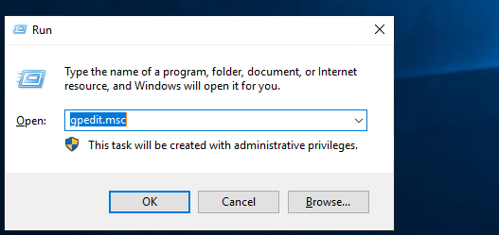
Expand local policy click on User Right Assignment –

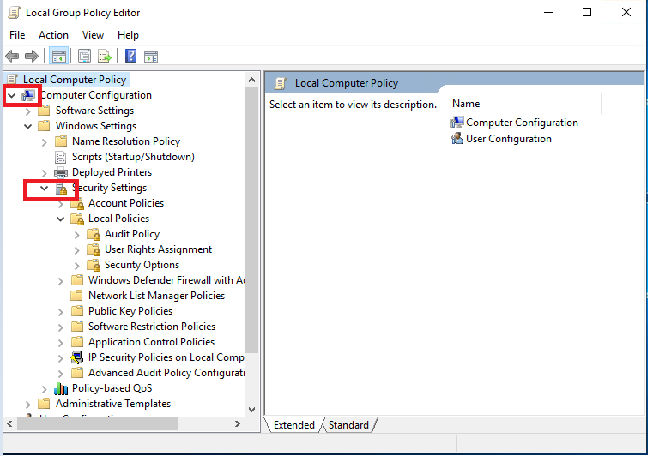

Allow log on through Remote Desktop services.

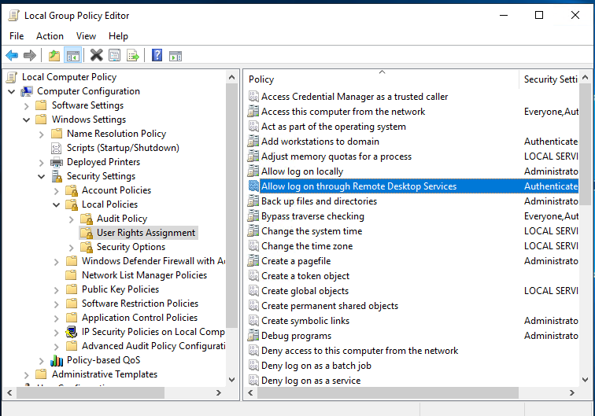

Add domain User

